Dante Alighieri Society: President’s Report to AGM 2019
Franco Papandrea – President - 4 April 2019

On behalf of the Committee, I am pleased to provide an overview of the Society’s activities over the past twelve months.

The year we have just completed has been one of significant success across most of our activities. It has been a year of both consolidation and change. We have sought to introduce subtle changes to some of our traditional activities concurrently with new activities as part of a strategy to broaden the age profile of the Society’s membership. The Diavoletti subcommittee is a crucial component of our strategy to attract younger people to the Society and encourage them to take positions of leadership on the Committee. In this regard, I am highly impressed by and commend the commitment and dedication of Alessandro Merola, vice president of the Society, and of Committee members, Cathy Perre, Catherine Pellegrino and Pam Perussich.

We are also trying to connect with younger generations via social media, primarily Facebook. We are currently using Facebook as our primary advertising channel for our language courses. The early signs are good, but we need to do more to derive the best possible advantage offered by social media.

In 2018, enrolments (200) in our language courses were 20% higher than in the previous year (166). The upward trend in enrolments has continued into the first term of this year. Participation in our conversation groups, while steady, is well below that of earlier years. The Committee is keen to explore options to enhance the appeal of conversation groups and what might be done to better integrate them with language courses. Feedback from conversation group leaders, regular participants and language course students will be crucial to achieving a better outcome.

We are devoting a significant effort to the development of a special language course for 2nd and 3rd generation Italian Australians whose only experience with the language is a dialect. The course will take account of that knowledge as a starting point for learning Italian. We proposed the project in response to an international competitive grant scheme for language and cultural projects run by DAS Rome and received the largest of the 28 grants approved.

The traditional format of our Thursday evening cultural presentations hasbeen augmented by live teleconferences with guests from notable Italian institutions with mixed success. There were also several culturally-related, events such as ‘aperitivo’ get-togethers and a ‘Carnevale’ celebration organised by the Diavoletti subcommittee.

The popular Dante Alighieri Musica Viva Choir plays a priceless role as the Society’s cultural ambassador in Canberra and the broader region. It invariably performs at significant Italian community events such as Republic Day celebration, the National Multicultural Festival, other general community events, and major functions organised by Italian associations. We are indebted to its musical director, managers, musicians, lead singers and the growing number of members for their commitment and dedication.

The Society is a major supporter of the Italian Cultural Centre at Forrest and of current efforts to convert into a well-functioning community facility providing a home for Italian cultural associations. We are working together with the centre’s managers in the development of plans to accommodate all of our needs and make the centre our permanent home. The importance of this aim is underscored by ongoing changes in the administration of the Notaras Multicultural Centre, which are increasingly constraining the Society’s operational flexibility.

The overall success of our activities is reflected in the Society’s solid financial performance over the past year. Tony Hanrahan, our Treasurer, will report on this shortly.

The success of our Society would not have been possible without the dedicated volunteers who generously devote a large chunk of their leisure time to manage the Society’s affairs and help run many of its activities. They are highly deserving of our deep gratitude. I commend particularly the dedication and commitment of:
- the members of the Committee — Gordon McCormick, who is retiring from the position of Vice-President merits a special mention and I thank for his dedication and support of the Society;
- the volunteer conversation group leaders;
- the editors of the Dante Review;
- the members who regularly respond to our calls for volunteers to help at community events; and
- all those who assist behind the scenes with the operation of technical equipment and other tasks..

I also gratefully acknowledge the dedication and support provided by our office staff and by the teachers of our language courses.

In closing, I thank all members for their loyal support of the ideals and vision of the Dante Alighieri Society.

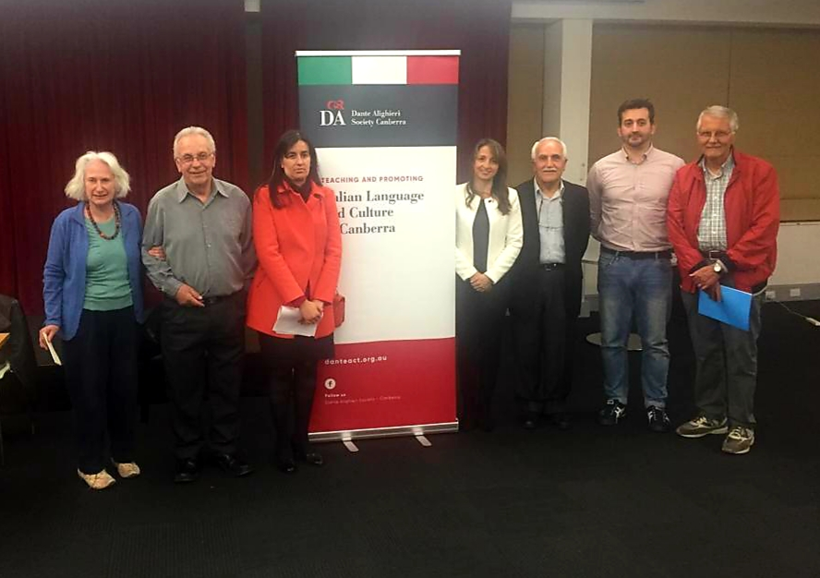

Da sinistra: Julie Docker, Sam Palma, Catherine Pellegrino, Cathy Perre, Franco Papandrea, Alessandro Merola, Luigi Catizone. Sono assenti: Tony Hanrahan and Pamela Perussich

FOTO DA METTERE IN PRIMA PAGINA

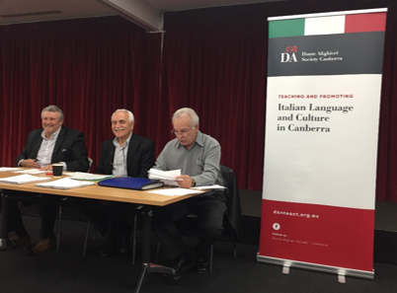

Al centro, il Presidente Franco Papandrea, alla sua destra il Tesoriere Tony Hanrahan ed alla sua sinistra il Segretario Sam Palma

